STEP:1 DOWNLOAD JENKINS.WAR FILE

LINK: <https://www.jenkins.io/download>

(don’t choose windows installer)

STEP: 2 MOVE YOUR JENKINS.WAR FILE TO

C:/ProgramFiles

STEP:3 OPEN CMD AND MOVE TO C:/ProgramFiles

* cd..
* cd..
* cd ProgramFiles

STEP:4 CHECK THE JAVA VERSION

* java –v

Note: Jenkins will work only with Java 8 or 11],if your machine contains JAVA 8 or 11 you can directly run the Jenkins by executing below command in cmd

* java –jar Jenkins.war

but if you your machine contains some higher version of java download java 8 or 11 and give the path manually as mentioned below

* .\Java\jdk1.8.0_202\bin\java –jar Jenkins.war

Once you will run the command Jenkins will start automatically and you will get secret code as below

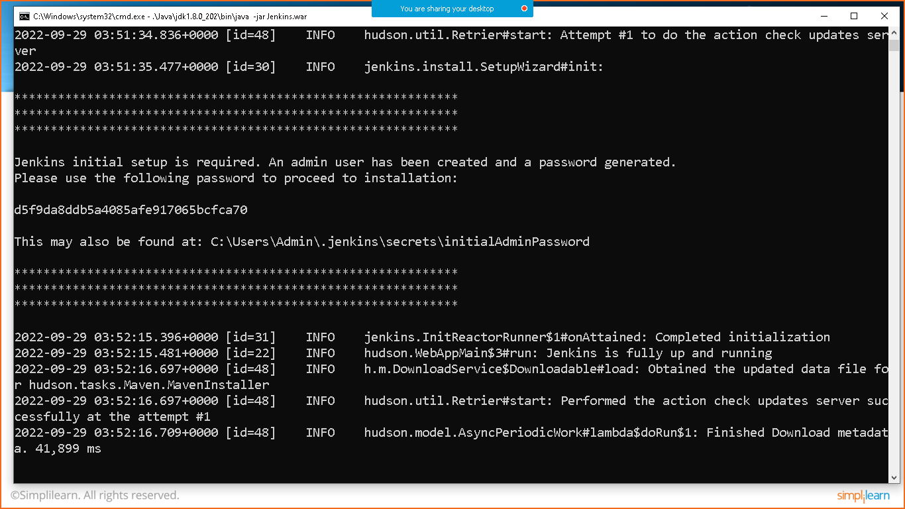

Goto the browser and type: localhost 8080 and hit enter

Copy the secret code and click on continue

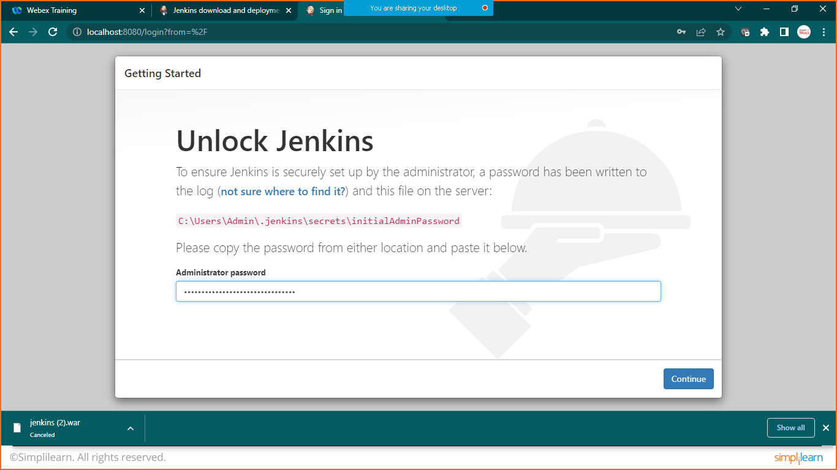

Click on install suggested plugins

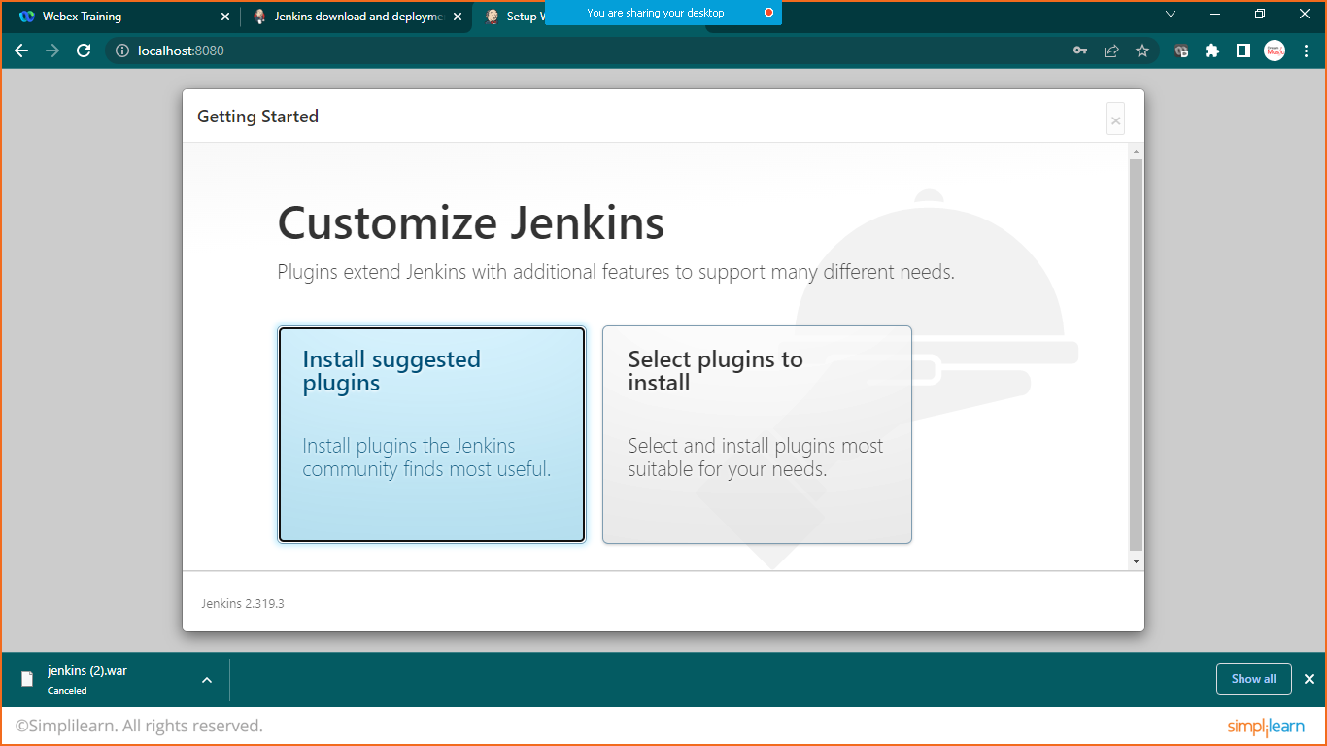

Wait until installation get completed

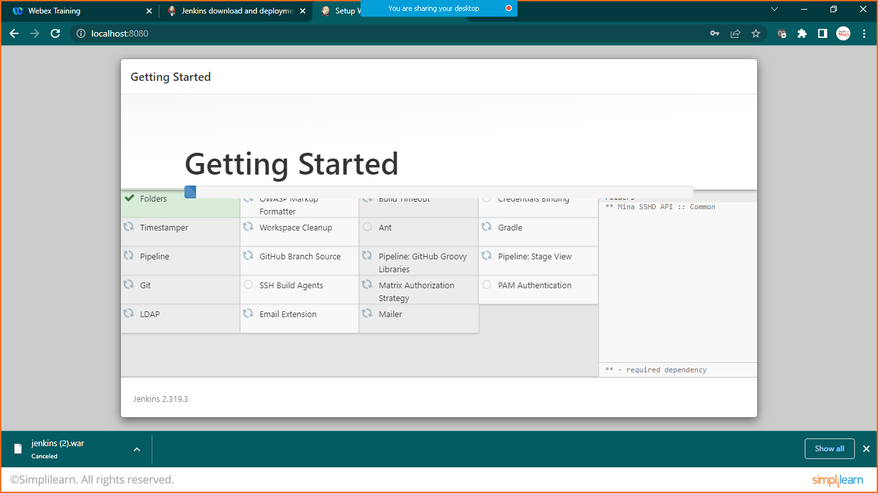

Provide your details

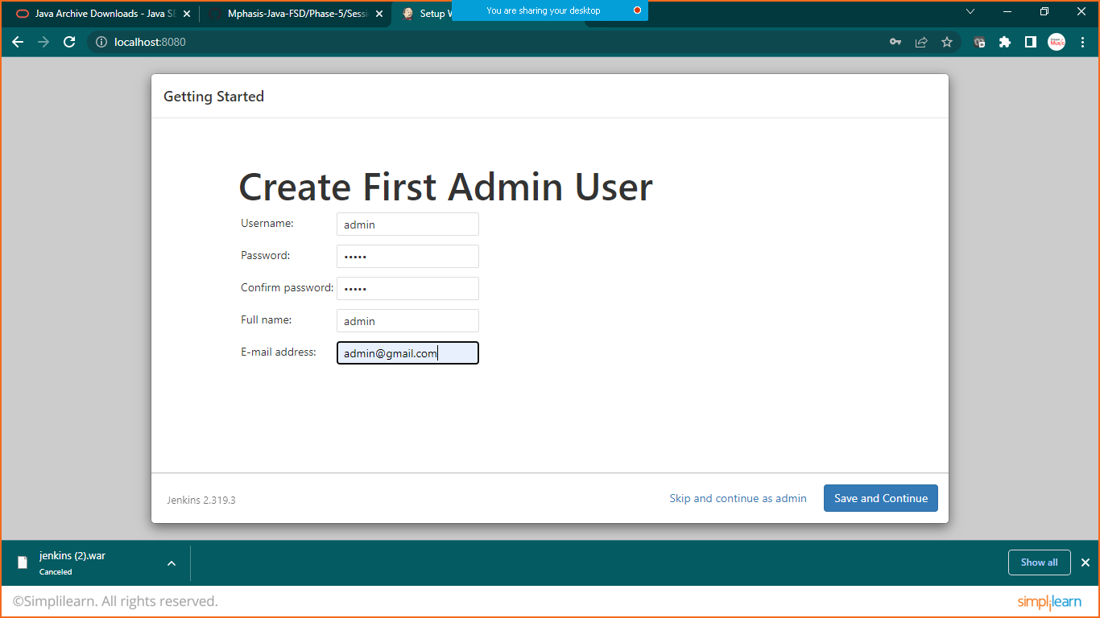

Click on save and continue

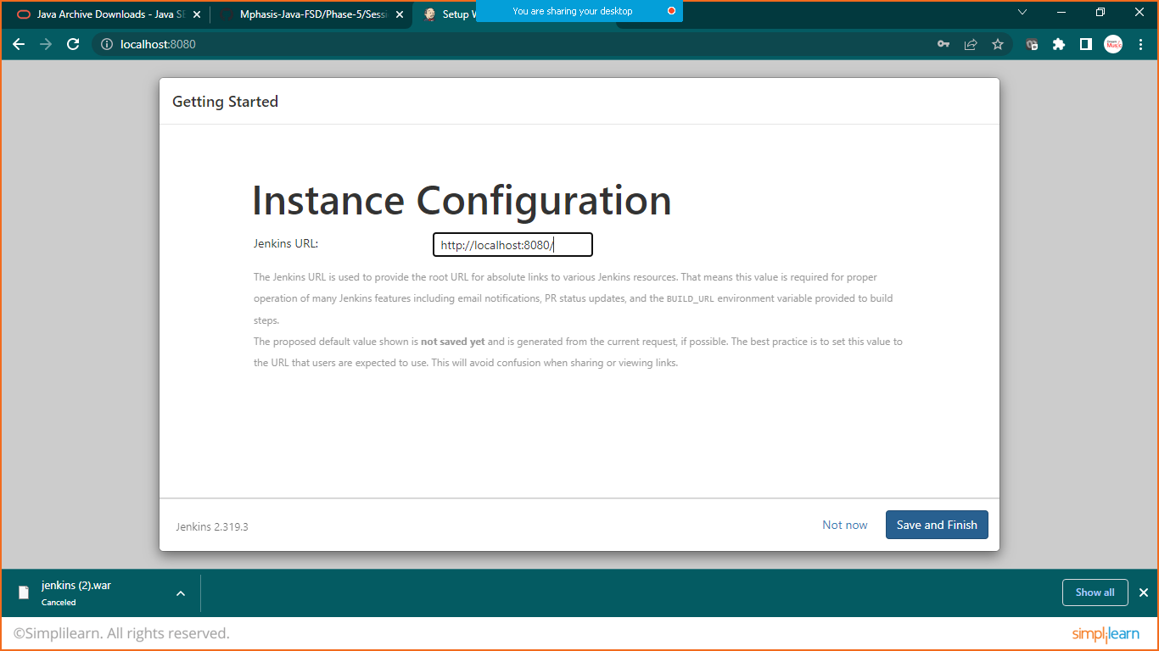

Click on save and finish

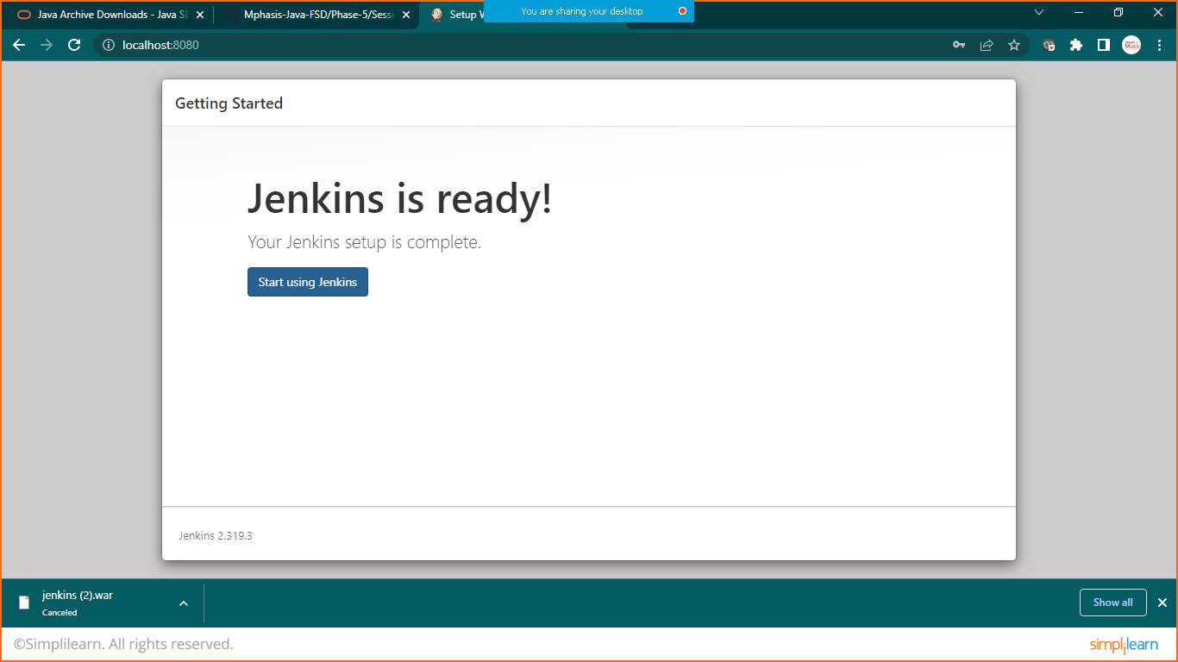

Click on Start using Jenkins

Click on manage Jenkins

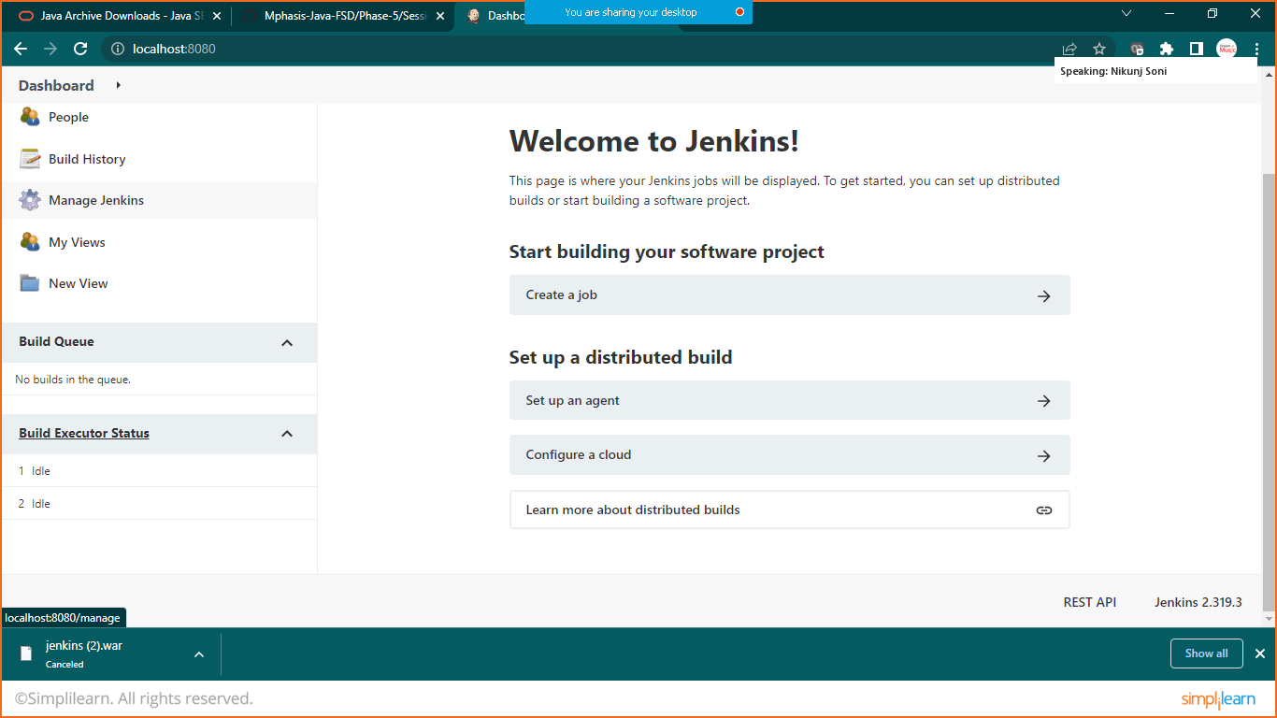

Click on manage plugins

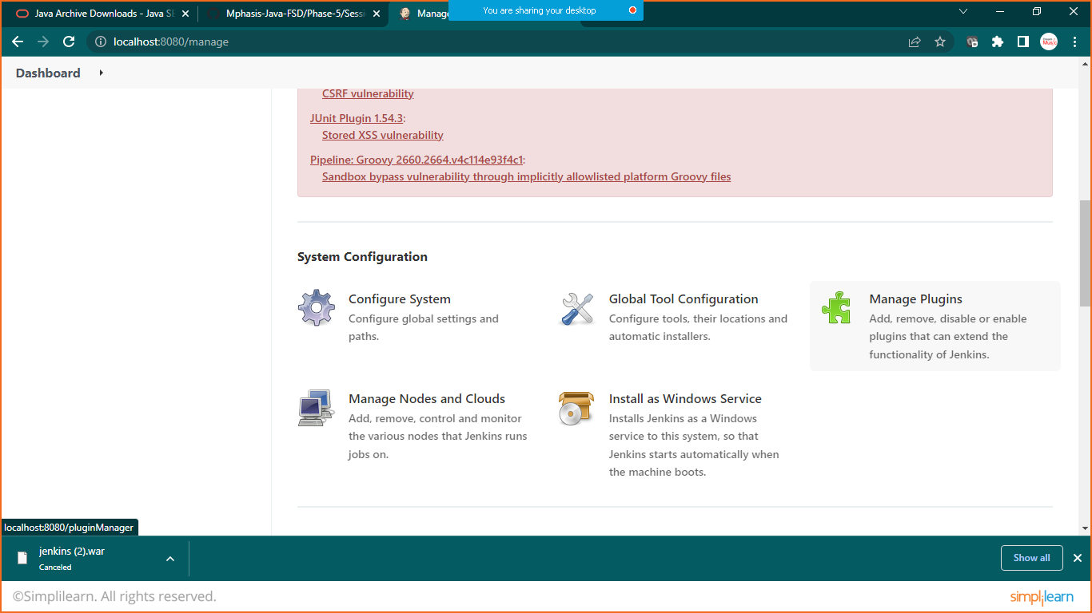

Search for Maven Integration

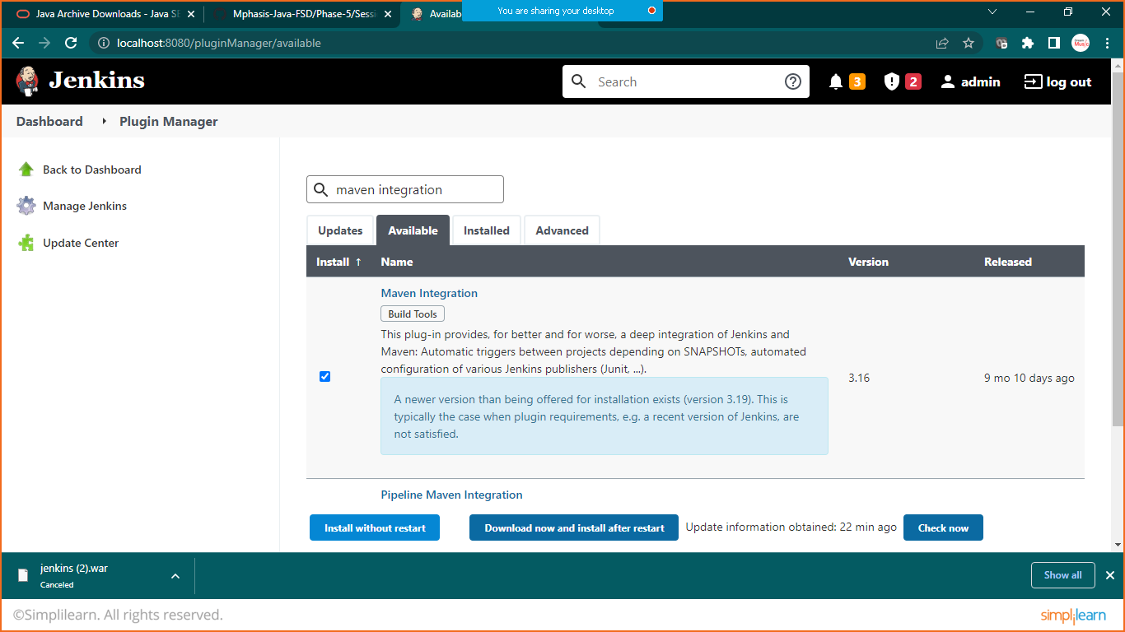click on install without restart

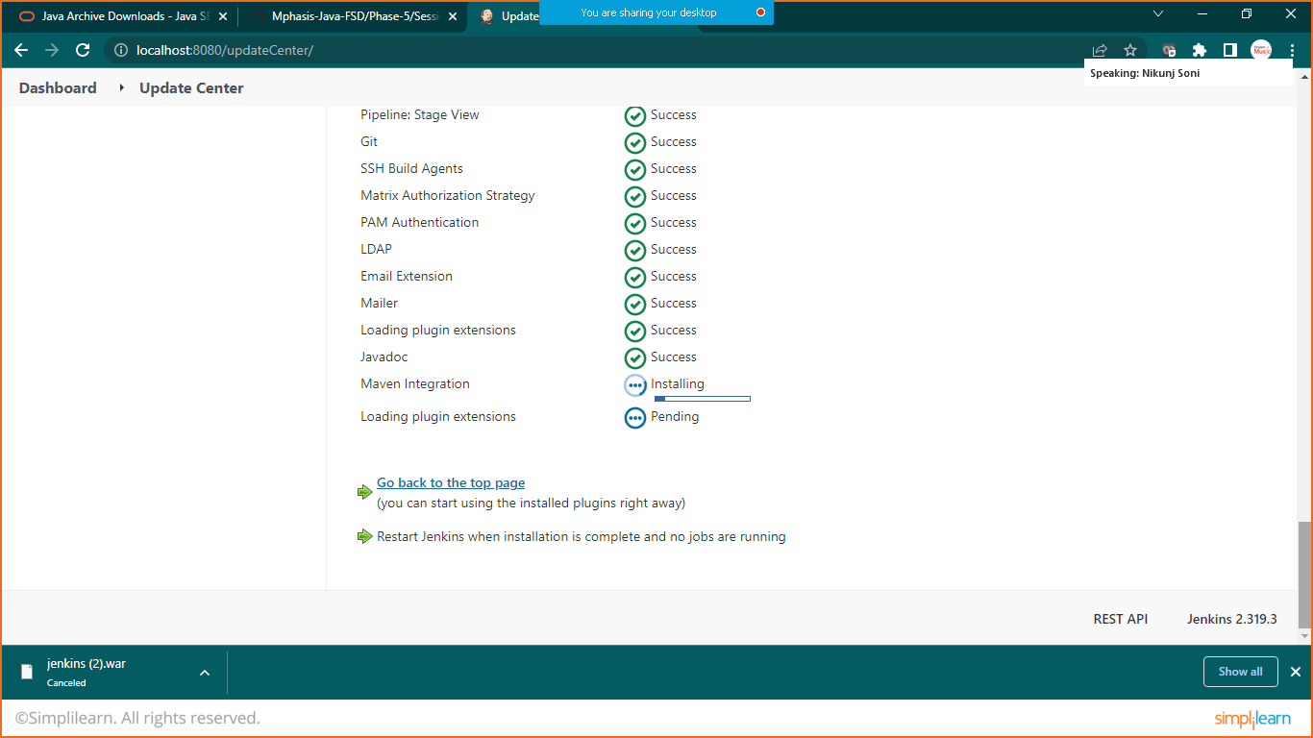

Once installation is done go to the dashboard

Again click on manage Jenkins and now click on global tool configuration

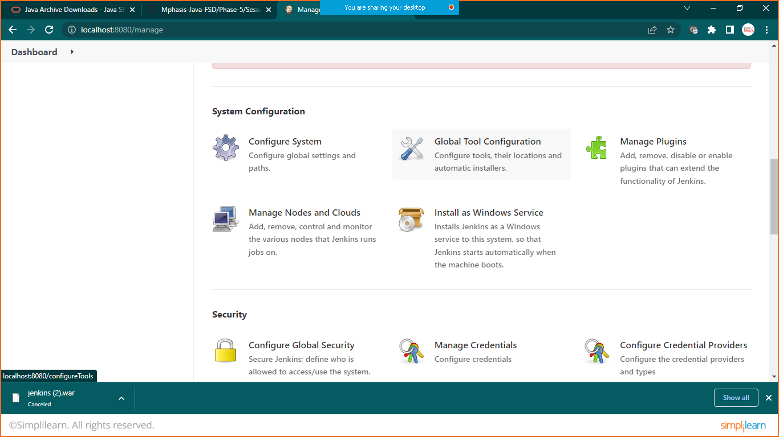

Goto JDK and provide your path

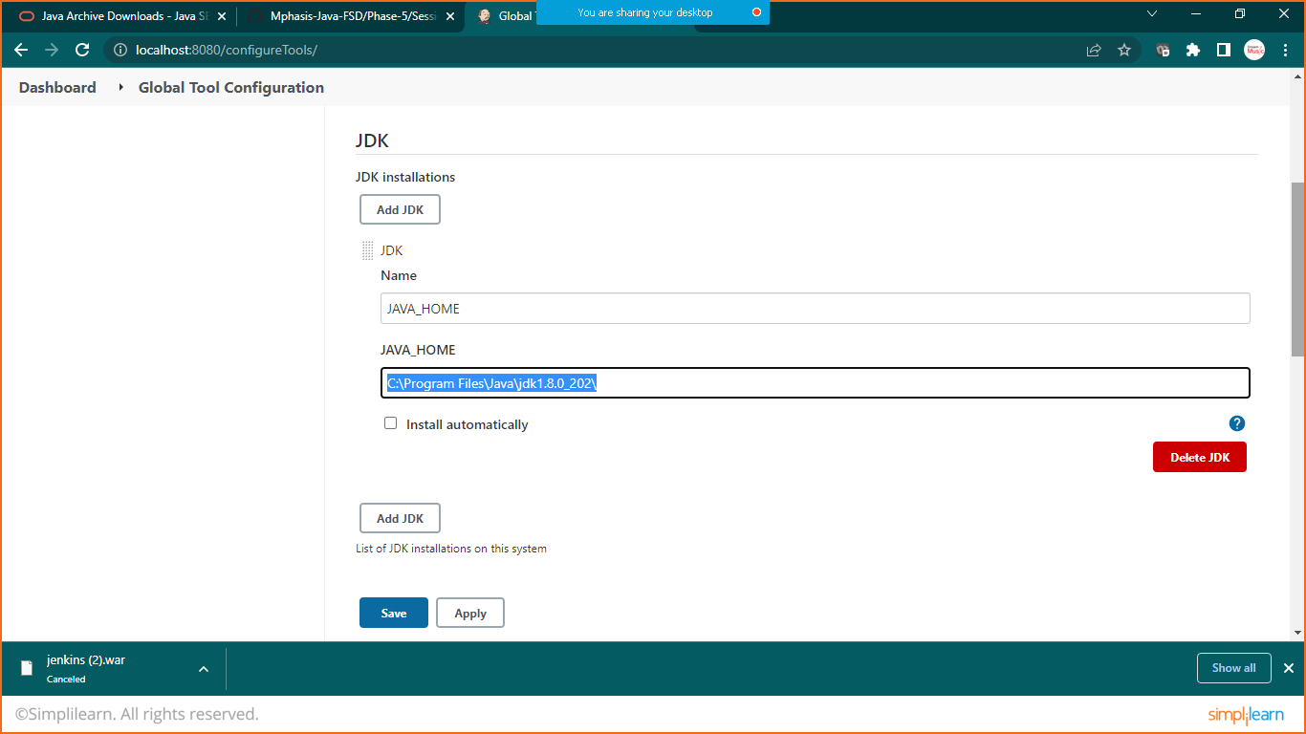

In maven

Choose your eclips version and add it for that goto>eclips>windows>preferences>maven>installation

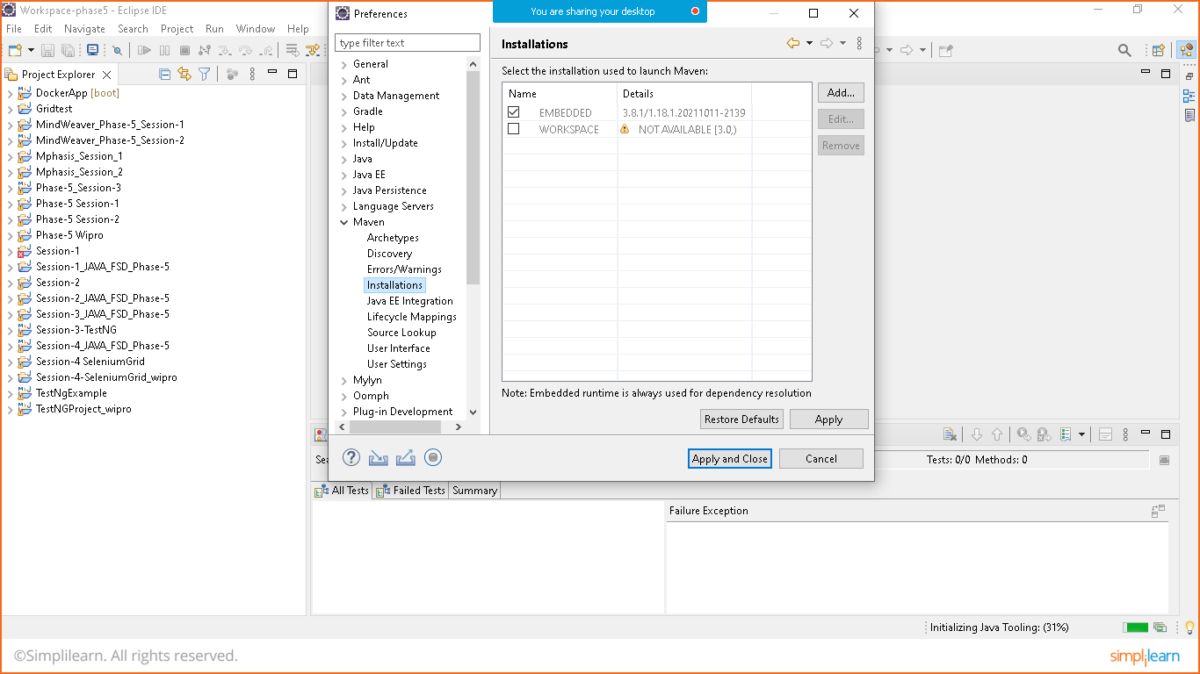

Version is: 3.8.1

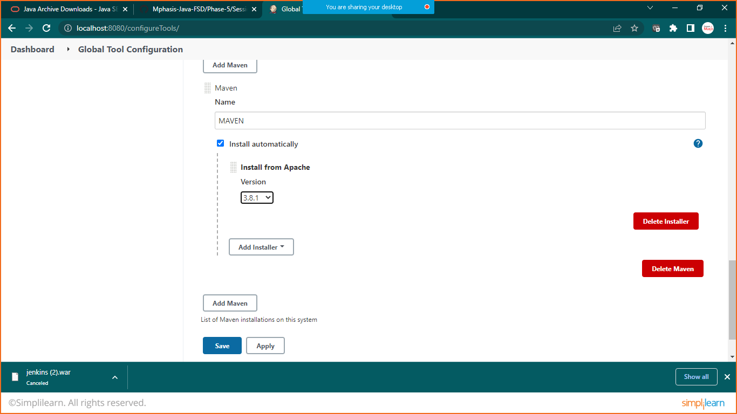

Click on save and apply

Create new job> maven project

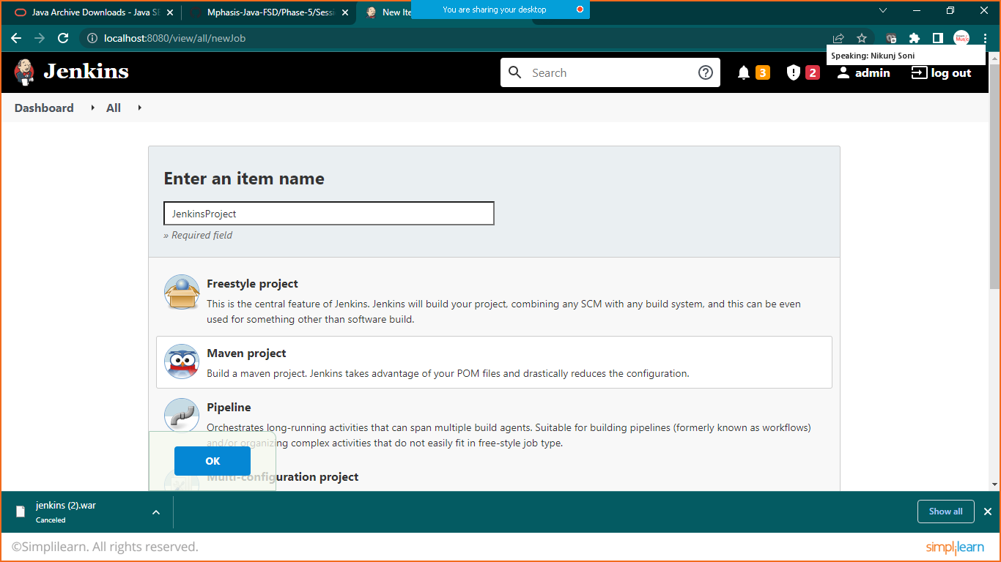

Give description and jump to presteps

And provide your project’s pom.xml file location

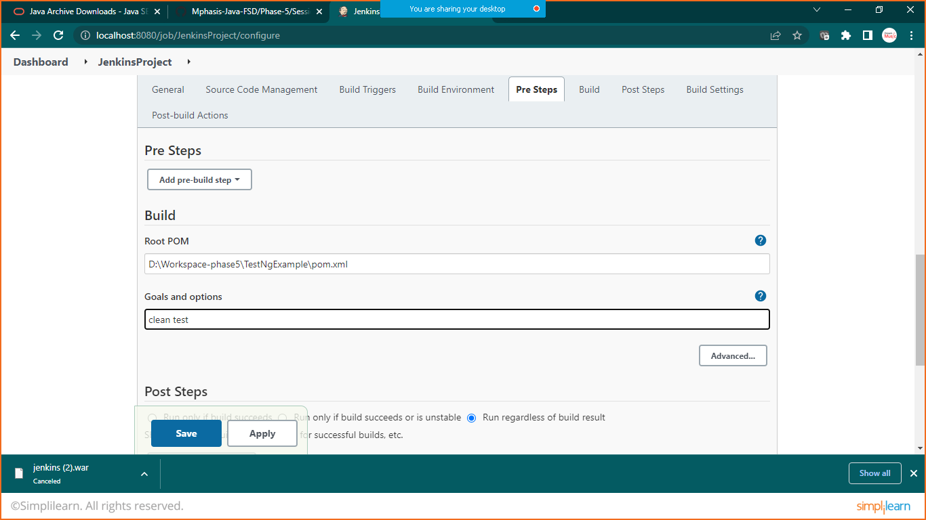

In goal and option write: clean test

Click on save

Click on build now